**Core Data iOS 7**

Core Data has been upgraded significantly in iOS7. [Read](http://www.techotopia.com/index.php/Working_with_iOS_7_Databases_using_Core_Data)

Create a searchable contact database with Core Data.

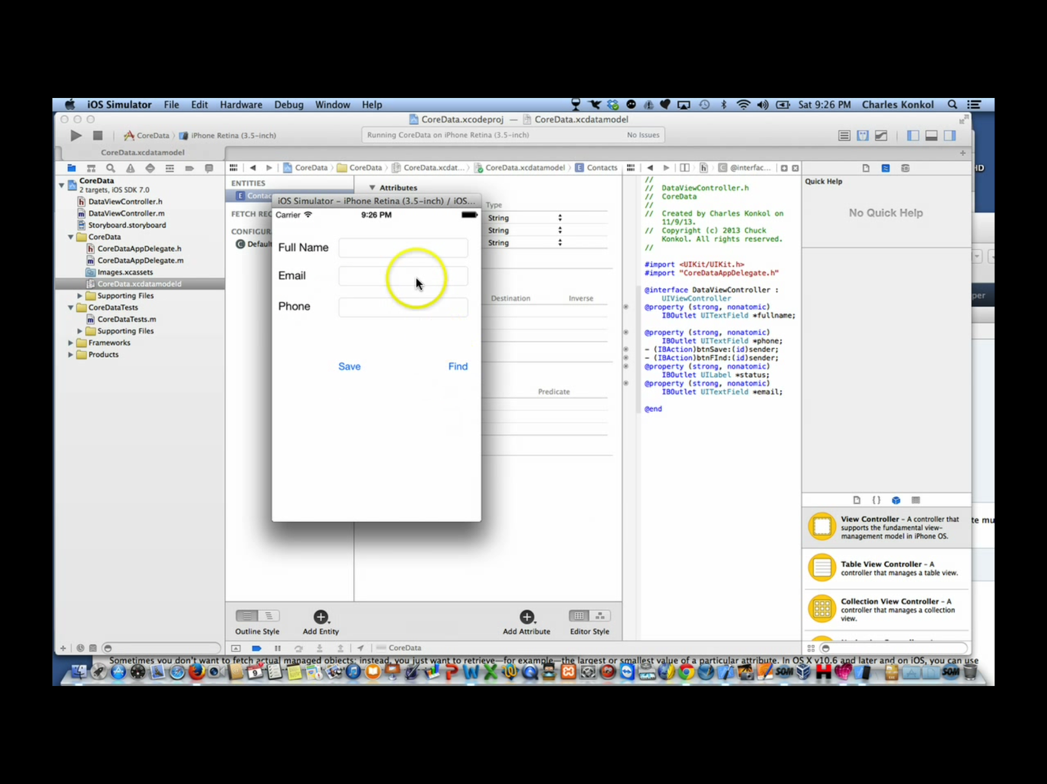

[Core Data is only available in Blank, Utility and Master/Detail projects]

1. Create New Blank Project, Select Core Data, Name CoreData
2. Name CoreData and add entities for coredata
   1. Select CoreData.xcdatamodeld
   2. Under Entities Select CoreData and Rename to Contact
   3. FullName – String
   4. Email – String
   5. Phone – String
3. Add StoryBoard
4. Add ViewControl
5. Add UIViewController Class and bind to View
6. Modify delegate.m launchOptions. Comment out all lines except return YES;

- (BOOL)application:(UIApplication *)application didFinishLaunchingWithOptions:(NSDictionary *)launchOptions

{

// self.window = [[UIWindow alloc] initWithFrame:[[UIScreen mainScreen] bounds]];

// Override point for customization after application launch.

//self.window.backgroundColor = [UIColor whiteColor];

// [self.window makeKeyAndVisible];

return YES;

}

1. Add Objects to View: 3 UITextFields, 1 UILabel & 2 Buttons (See Cover Page for Layout)
2. Bind outlets and actions to .h and .m
   1. UITextFields - Outlets
      1. fullname
      2. email
      3. phone
   2. UILabel - OutLet
      1. status
   3. UIButtons - Actions
      1. btnFind
      2. btnSave
3. Add #import “[nameofproject]appdelegate.h” into [nameofviewcontroller].h
4. Add code to save

- (IBAction)btnSave:(id)sender {

//Load CoreData Contacts Table

CoreDataAppDelegate *appDelegate = [[UIApplication sharedApplication] delegate];

NSManagedObjectContext *context = [appDelegate managedObjectContext];

NSManagedObject *newContact;

newContact = [NSEntityDescription insertNewObjectForEntityForName:@"Contacts" inManagedObjectContext:context];

//Connect TextFields to DataFields

[newContact setValue: fullname.text forKey:@"fname"];

[newContact setValue: email.text forKey:@"email"];

[newContact setValue: phone.text forKey:@"phone"];

//Clear testfields after save

fullname.text = @"";

email.text = @"";

phone.text = @"";

NSError *error;

//Save

[context save:&error];

status.text = @"Contact saved";

}

1. Add code to btnFind

- (IBAction)btnFInd:(id)sender {

CoreDataAppDelegate *appDelegate = [[UIApplication sharedApplication] delegate];

NSManagedObjectContext *context = [appDelegate managedObjectContext];

NSEntityDescription *entityDesc = [NSEntityDescription entityForName:@"Contacts" inManagedObjectContext:context];

NSFetchRequest *request = [[NSFetchRequest alloc] init];

[request setEntity:entityDesc];

//<http://stackoverflow.com/questions/2036094/case-insensitive-core-data-contains-or-beginswith-contraint>

//<https://developer.apple.com/library/mac/documentation/Cocoa/Conceptual/Predicates/Articles/pSyntax.html>

NSPredicate *pred =[NSPredicate predicateWithFormat:@"(fname CONTAINS[cd] %@)", fullname.text];

[request setPredicate:pred];

NSManagedObject *matches = nil;

NSError *error;

NSArray *objects = [context executeFetchRequest:request error:&error];

if ([objects count] == 0) {

status.text = @"No matches";

} else {

matches = objects[0];

fullname.text = [matches valueForKey:@"fname"];

email.text = [matches valueForKey:@"email"];

phone.text = [matches valueForKey:@"phone"];

status.text = [NSString stringWithFormat: @"%@ matches found", (unsigned long)[objects count]];

}

}